Wirral Schools’ Library Service
Order form for books and other resources for
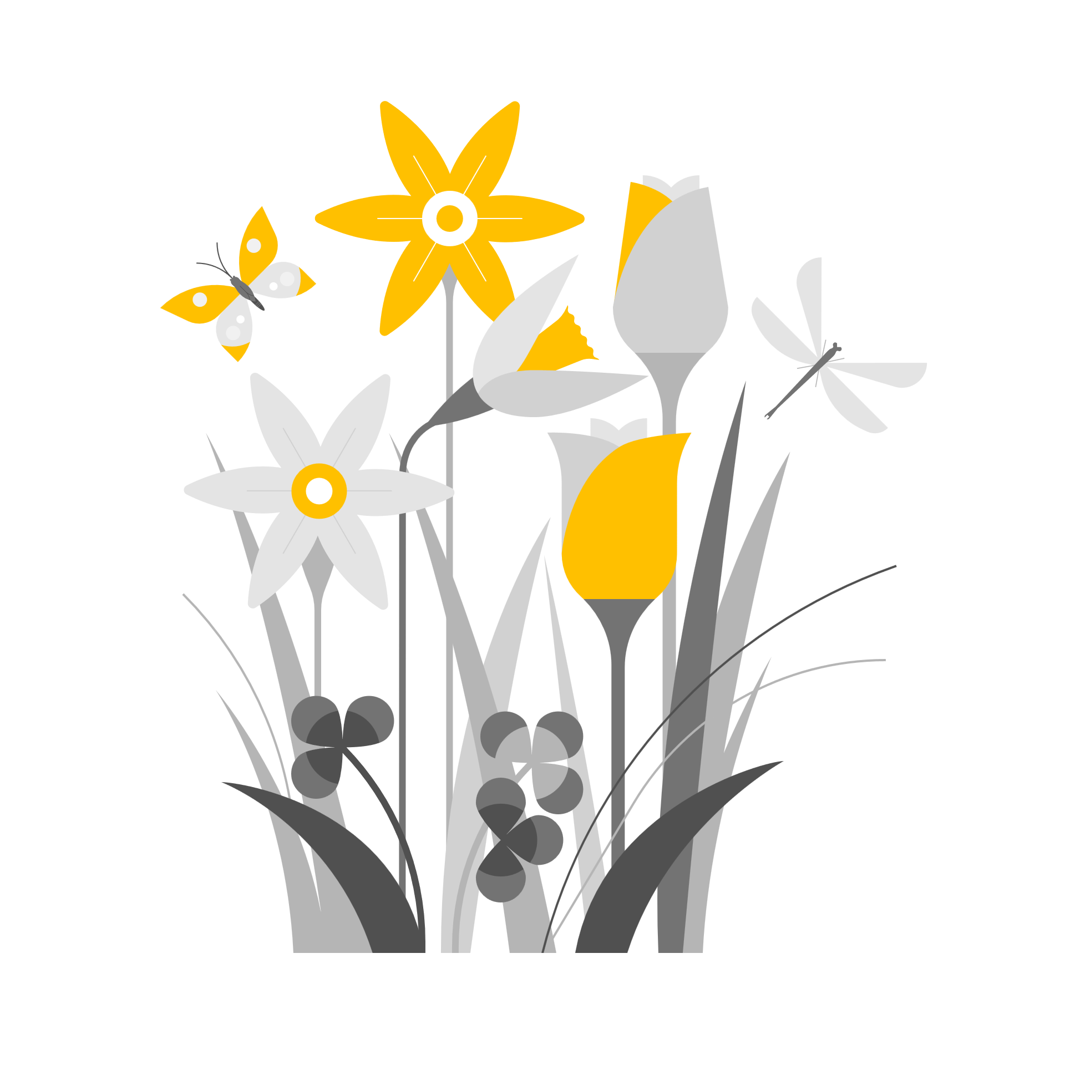 Spring Term 2027

School………………………………………………………………………………………………….
School Contact for SLS………………………………………………………………….

It is very helpful to the SLS Team if teachers can submit their requests on a single set of forms for the whole school. Please return all requests to sls@wirral.gov.uk as soon as possible. Please note Reading for Pleasure collections are only delivered in the Autumn term but teachers are very welcome to collect or exchange RfP books by visiting the SLS Library at any time through the year. Thank You.

