Wirral Schools’ Library Service
Order form for books and other resources for
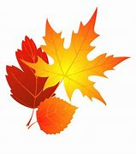 Autumn Term 2025
School………………………………………………………………………………………………….
School Contact for SLS………………………………………………………………….

It is very helpful to the SLS team if requests are submitted on a single form for the whole school wherever possible. Please return all requests to sls@wirral.gov.uk as soon after the May half term as possible. Thank You.

